Name: ___________________________________________ Date: _____________________ Block: _________

World History Final
Study Guide

- Describe the political structure of Mesopotamia. (Remember Hammurabi!)

- Describe the relationship between religion and political authority in Ancient Egypt.

- Explain the concepts developed by the Hebrews and Zoroastrianism.

- Describe the early trading networks in the Mediterranean Sea. (Remember the Phoenicians!)

- Explain the development and importance of writing. (Remember cuneiform, hieroglyphics, and the Phoenician alphabet!)

- Describe the development of Chinese civilization under the Zhou and Qin.

- Explain the impact of Confucianism on Chinese culture. (Remember the examination system!)

- Compare the origins and structure of the Greek polis, the Roman Republic, and the Roman Empire.

- Identify the ideas and impact of these important individuals:
  - Socrates

  - Alexander the Great

  - Julius Caesar

  - Augustus Caesar

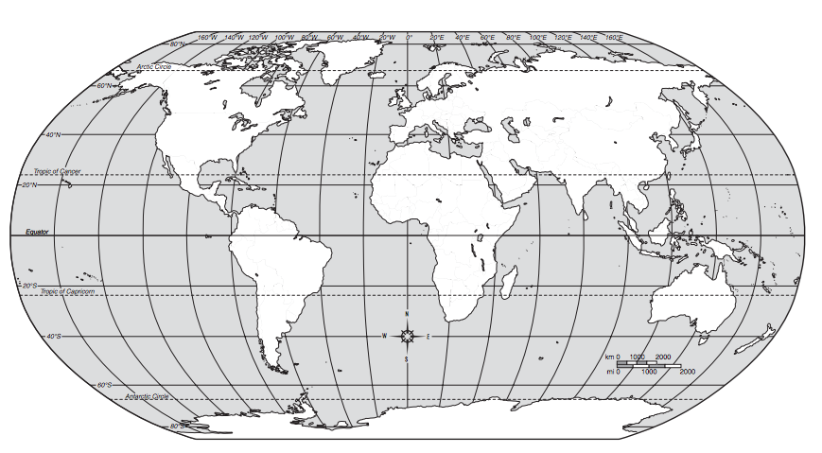
- Identify the Muslim trade routes to India, China, Europe, and Africa. What were the economic impacts of the Muslim trade?

- Explain the reasons for the split between Sunni and Shia Muslims.

- Describe the impact of the Crusades on both the Islamic World and Europe.

- Explain the rise and fall of the Inca and Aztec Empires.

- Compare the government and religion of two of the American Empires.

- Identify the artistic and scientific achievements of Leonardo da Vinci.

- Explain the main characteristics of humanism.

- Analyze the impact of the Protestant Reformation. (Remember Martin Luther!)

- Describe the English Reformation.

- Explain the Scientific Revolution.

- Identify the causes and results of the following revolutions:
  - France

  - Latin America

- Identify the major ideas of the Enlightenment.

- Explain the importance of Gutenberg and the invention of the printing press.

- Define the Columbian Exchange and its global economic and cultural impact.

- Explain the interaction of China and Japan with westerners.

- Analyze the process and impact of industrialization in England.

- Describe the Boxer Rebellion.

- Identify the causes of WWI.

- Analyze the rise of nationalism as seen in the ideas of Sun Yat-sen.

- Describe the totalitarian governments of Germany and the Soviet Union.

- Explain the long-term outcome of the peace conference after World War II.

